

HỌC VIỆN CÔNG NGHỆ BƯU CHÍNH VIỄN THÔNG
KHOA CÔNG NGHỆ THÔNG TIN I



Môn học:
Phân tích và thiết kế hệ thống thông tin

Giảng viên | : Đỗ Thị Bích Ngọc
Họ và tên | : Nguyễn Thiên Thịnh
Lớp | : E22HTTT
Mã sinh viên | : B22DCCN835

Ha Noi – 2025

SUBJECT NO. 01

A Library management system of a University (LibMan) allows to manage the common documents (books, textbooks, journals, etc.), manage borrowing and returning activities and status performed by students. The system allows:
- Management staff: view statistical reports of status of documents and readers via loan as well as imported documents from suppliers.
- Library staff: manage documents, readers, suppliers (add, delete, change), search, lend documents, receive and return documents from readers, import documents from suppliers.
- Readers: borrow documents, return documents directly to staff, search for document information, register for online reader cards.

Considering two modules and answering questions:
- Reader finds document information: selects the document search menu → enters the document's name to search → the system displays a list of documents whose name contains the entered keyword → clicks on a document to view details → the system shows detailed information about the document.
- Library staff lends documents to readers: selects the document loan menu → scan reader card (or search by code) → Repeats the following steps for all borrowed documents: scan document code (or search by code) → repeats until all borrowed materials are finished, then submit → prints the loan slip and delivers it to the reader.

PART I: SPECIFICATION 4
1. Glossary list 4
2. Project Information 9
a. Objective 9
b. Scope 9
c. How Do the Modules Work 9
3. Use case diagrams 12
a. General use case diagram 12
b. Module 1: Reader Finds Document Information 13
c. Module 2: Library Staff Lends Documents to Readers 14
PART II: ANALYSIS 16
1. Write Use Cases Scenario 16
a. Reader finds document information 16
b. Library staff lends documents to readers 17
2. Entity Classes 20
3. Boundary Class and Control Class 24
a. Reader finds document information 24
b. Library staff lends documents to readers 25
4. Activity Modeling 27
a. Reader finds document information 27
b. Library staff lends documents to readers 28
PART III: DESIGN 31
1. Entity Class Design 31
2. Database Design 31
3. Detailed Design for module 32
a. Static Design for module reader finds document information 32
b. Static Design for Library staff lends documents to readers 35
4. Activity Design 38
a. Module reader finds document information 38
b. Module library staff lends documents to readers 40
5. Package Design 42
6. Deployment Desgin 43
PART IV: SYSTEM IMPLEMENTATION 45
1. Project Organization 45
a. Controller Package 45
b. Dao (Data Access Object) Package 45
c. Model Package 45
d. Webapp Directory 46
e. Libraries 46
2. Interface 50
a. Module reader finds document information 50
b. Module library staff lends documents to readers 53
3. Coding 55

PART I: SPECIFICATION

1. Glossary list
- Actor: Refers to human users or roles interacting with the system (people or groups performing actions).
- Action: Refers to processes, operations, or activities performed by actors or the system.
- Object: Refers to entities or items managed by the system (physical or digital items like documents or records).
- System Component: Refers to parts of the software system, such as menus, interfaces, or outputs.
The table includes the term name, its detailed meaning based on the system description, and the category/type.

Name | Meaning | Type
LibMan | The University Library Management System software. It integrates core library operations: cataloging and managing documents, supporting borrowing/returning transactions, managing users and suppliers, generating reports, and providing search and access interfaces for staff and readers. | System Component
Management Staff | Authorized administrative personnel (library managers) who oversee system usage. They primarily monitor operations through statistical reports, track document availability, supervise borrowing/returning trends, and review supplier imports for decision-making. | Actor (Human)
Library Staff | Operational staff responsible for executing day-to-day library functions. They manage records of documents, readers, and suppliers; process borrow/return transactions; handle importing of new documents; and assist readers in using the system. | Actor (Human)
Readers | End-users of the library (students, researchers, or general users) who utilize the system to search for documents, borrow and return items (via staff), and register for reader cards (online or physical) to gain borrowing privileges. | Actor (Human)
Suppliers | External vendors or organizations providing the library with new documents. Their information is recorded and managed by library staff during the import process (add, update, delete). | Actor (Human/External Entity)
Documents | The core library assets stored in the system: books, journals, textbooks, comics, and other materials. Each document has metadata (title, author, status, availability) and can be searched, borrowed, returned, or imported. | Object
Borrowing | The process in which readers obtain documents temporarily. Library staff initiate this process by scanning the reader’s card and the document codes. Once completed, the system generates a loan slip for confirmation. | Action
Returning | The process of readers giving borrowed documents back. Library staff verify the returned items, update their availability status in the system, and ensure records are updated correctly. | Action
Loan Slip | A system-generated confirmation (usually printed or digital) produced after a borrowing transaction. It contains transaction details such as reader information, borrowed documents, dates, and due return schedule. | Object
Statistical Reports | Summaries generated automatically by the system for managerial review. They include document circulation reports, reader activity statistics, and supplier import summaries to support operational analysis and decision-making. | Object
Reader Card | A unique identifier for readers, either physical (plastic card with barcode/ID) or digital (online registration). It is used to authenticate the reader’s identity during borrowing and returning processes. | Object
Document Code | A unique system-generated identifier (barcode or alphanumeric ID) assigned to each document. It is used for scanning, searching, borrowing, returning, or managing inventory. | Object
Import Documents | The action executed by library staff to add new materials into the system from suppliers. It updates the catalog with new document details and increases inventory. | Action
Search Documents | A process performed by readers or staff to locate documents by entering keywords (e.g., title, author, genre). The system returns a list of matching results, which can be browsed or viewed in detail. | Action
Lend Documents | A specific borrowing action managed via the Document Loan Menu. Staff repeatedly scan the reader’s card and multiple document codes, confirm the selection, and finalize the process by printing or saving a loan slip. | Action
Receive Documents | The action taken by staff during the return process. Staff accept documents physically, scan their codes, and update the system to reflect their availability and condition. | Action
Register Online Reader Cards | A self-service process where readers use the system to apply for or activate a digital reader card. The system verifies and creates a reader record, granting borrowing privileges. | Action
Document Search Menu | A user interface in the system that allows readers to enter search keywords for finding documents. It provides access to search results and links to detailed document information. | System Component
Document Loan Menu | A user interface in the system available to library staff to initiate and process lending operations, including scanning IDs, documents, and printing loan slips. | System Component
Detailed Information | A system-generated display page showing complete metadata of a selected document, including title, author, publisher, category, availability, borrowing history, and status. | Object
Keyword | A text string entered by readers or staff to perform searches. It may represent part of a document’s title, author name, or subject. Keywords are matched against the system database to retrieve results. | Object
Manage Documents (Add/Delete/Edit) | Operations used by Library Staff to maintain the document catalog, including adding new titles, removing old ones, and updating metadata. | Action
Manage Readers (Add/Delete/Edit) | Operations used by Library Staff to maintain the user database, including registering new readers, deleting expired accounts, and updating information. | Action
Manage Suppliers (Add/Delete/Edit) | Operations used by Library Staff to maintain the list of vendors, including adding new suppliers and updating their contact information. | Action
Document Status | An attribute of a document specifying its current availability (e.g., "Available", "On Loan"). This is viewed by staff and readers. | Object
Search Results List | A system-generated list displayed after a reader or staff performs a search. It shows documents matching the keyword, allowing selection for details. | Object
Scan Reader Card | The action performed by Library Staff (often with a scanner) to identify and authenticate a reader in the system using their Reader Card. | Action
Scan Document Code | The action performed by Library Staff (often with a scanner) to identify a specific document using its unique Document Code during checkout/check-in. | Action
Search by Code | An alternative method (to scanning) for Library Staff to manually input a Reader Card ID or Document Code to find the corresponding record. | Action
Submit (Loan) | The action taken by Library Staff to finalize the list of documents being borrowed, triggering the system to record the transaction and prepare for printing. | Action
Print Loan Slip | The action taken by Library Staff after submitting a loan, where the system generates and prints a physical copy of the Loan Slip for the reader. | Action

2. Project Information

a. Objective
The primary objective of the LibMan system is to streamline and automate the management of university library resources, ensuring efficient handling of documents, user interactions, and operational reporting. It aims to facilitate seamless borrowing and returning processes for readers, enable library staff to perform administrative tasks with minimal errors, and provide management staff with data-driven insights for decision-making. Ultimately, the system seeks to improve accessibility to library materials, reduce manual workloads, track document status in real-time, and enhance overall user satisfaction for students, staff, and suppliers.

b. Scope
The scope of LibMan is limited to core library operations within a university setting. It includes:
- Management of common documents (books, textbooks, journals, comics) and related entities like readers and suppliers.
- Handling borrowing, returning, searching, and importing activities.
- Role-based access: Management staff for viewing reports; library staff for full CRUD (create, read, update, delete) operations on documents, readers, and suppliers; readers for self-service searching and registration.
- Integration of two specific modules: reader document search and staff document lending.
- Exclusions: The system does not cover advanced features like digital document access (e-books), inter-library loans, fine management, or integration with external payment systems. It focuses on physical document handling and basic online registration, without mobile app support or AI-based recommendations. suppliers.

c. How Do the Modules Work
The system includes two key modules, each with a step-by-step workflow:
- Reader Finds Document Information Module:
- The reader selects the "Document Search Menu" from the system's interface.
- They enter a keyword (part of the document's name) into the search field.
- The system processes the query and displays a list of documents whose names contain the entered keyword, showing basic details like title and availability.
- The reader clicks on a specific document from the list.
- The system then retrieves and displays detailed information about the selected document, such as full description, author, publication date, status (e.g., available or on loan), and location.
- This module supports self-service information access without requiring staff intervention, promoting user independence.
- Library Staff Lends Documents to Readers Module:
- The library staff selects the "Document Loan Menu" from the system's interface.
- They scan the reader's card (or search by the reader's code) to identify and verify the borrower.
- For each document being borrowed, the staff scans the document code (or searches by code) to add it to the loan transaction.
- This scanning/search step repeats for all documents the reader wishes to borrow.
- Once all items are added, the staff submits the transaction.
- The system processes the loan, updates document and reader statuses, generates a loan slip with details (e.g., borrowed items, due dates), prints it, and delivers it to the reader.
- This module ensures accurate tracking of loans, prevents errors in manual entry, and integrates with the overall document status management.
These modules operate sequentially within user sessions, relying on the system's database for real-time updates and validations (e.g., checking if a document is available before lending).
- Information about Objects: The system manages several key objects (entities) with associated attributes:
- Documents: Core items like books, textbooks, and journals. Attributes include name/title, code (unique ID), genres, author, publication details, status (available, on loan, damaged), location in the library, and import source (from suppliers).
- Readers: University students or users. Attributes include name, code/ID, contact information, reader card details (physical or online-registered), borrowing history, current loans, and status (active or suspended).
- Suppliers: External providers of documents. Attributes include name, contact details, supplier ID, history of imported documents, and transaction records.
- Loans: Records of borrowing transactions. Attributes include loan ID, associated reader and documents, borrow date, due date, return date (if applicable), and status (active or returned).
- Reports: Generated summaries for management. Attributes include aggregated data on document status (total available vs. loaned), reader activity (number of loans per user), and imports (volume from each supplier over time).
- Reader Cards: Identification objects. Attributes include card ID, linked reader, registration date (for online cards), and validity status.
These objects are stored in a database, with unique identifiers ensuring traceability.
- Relationships among Objects: The objects in LibMan are interconnected through various relationships to support system functionalities:
- Reader and Documents: A many-to-many relationship via loans - a reader can borrow multiple documents, and a document can be borrowed by multiple readers over time (but only one at a time). This is tracked through loan records, linking reader IDs to document codes with timestamps.
- Library Staff and Objects (Documents, Readers, Suppliers): One-to-many - staff can manage (add/delete/change) multiple documents, readers, or suppliers, but each object is managed by any authorized staff without exclusive ownership.
- Suppliers and Documents: One-to-many - a supplier can provide multiple documents through imports, and each document is linked to its supplier for tracking procurement history.
- Loans and Loan Slips: One-to-one - a loan transaction generates one loan slip, which serves as a physical or digital record summarizing the loan details.
- Reports and Objects: Aggregative - reports derive from multiple objects (e.g., a statistical report on loans aggregates data from readers, documents, and loan records; import reports link suppliers and documents).
- Reader Cards and Readers: One-to-one - each reader has one card (physical or online), which is used as a key for authenticating borrowing/returning actions and linking to loan relationships.

3. Use case diagrams

a. General use case diagram
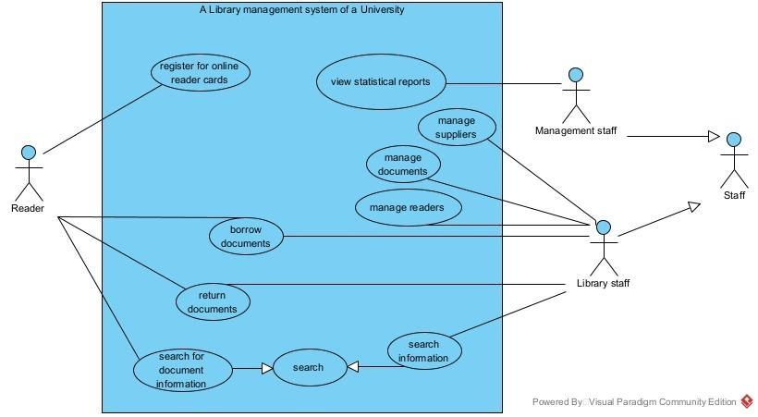
- Actor: Reader
- Register for online reader cards: This UC allows a Reader to self-register for a new account and reader card through the system's online interface.
- Borrow documents: This UC describes the process of a Reader borrowing documents, an action that is mediated and processed by the Library Staff.
- Return documents: This UC describes the process of a Reader returning borrowed documents, which are received and updated in the system by the Library Staff.
- Search for document information: This UC allows a Reader to search for and view detailed information about documents (such as title, author, status) available in the system.
- Actor: Management Staff
- View statistical reports: This UC allows Management Staff to view reports and statistics regarding borrowing/returning trends, document status, and reader activity.
- Actor: Library Staff
- Manage suppliers: This UC allows Library Staff to add, delete, or update the information of suppliers who provide documents to the library.
- Manage documents: This UC allows Library Staff to add, delete, or update the detailed information and status of documents (books, journals, etc.) within the system.
- Manage readers: This UC allows Library Staff to create, delete, or update the profiles and account information of Readers.
- Search information: This UC allows Library Staff to search for general information within the system (which could include reader information, documents, etc.) to support operational tasks.

b. Module 1: Reader Finds Document Information
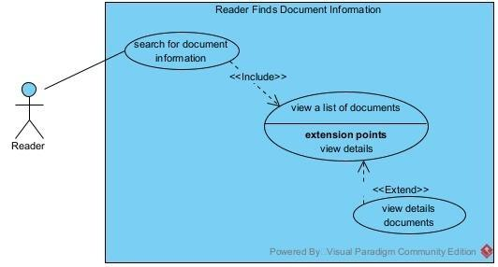
This diagram shows the "Reader" actor interacting with use cases related to searching and viewing document details. The main flow involves inclusion and extension relationships to handle search results and optional detailed views.
- Search for Document Information
- Actor: Reader
- Relationships: Includes "View a List of Documents" (mandatory step in the process).
- Description: This is the initiating use case where the reader begins the process of locating document information. The reader selects the document search menu and enters a keyword (part of the document's name). The system processes the query to retrieve matching documents, leading directly into viewing the results list. This use case ensures users can efficiently query the library's catalog without staff assistance.
- View a List of Documents
- Actor: Reader
- Relationships: Included by "Search for Document Information"; has extension points for "View Details" (optional extension).
- Description: Following a search, the system displays a list of documents whose names contain the entered keyword, including basic details like titles and availability. This acts as an intermediate step, allowing the reader to browse results. Extension points enable further interaction, such as selecting an item to view more details if desired.
- View Details
- Actor: Reader
- Relationships: Extends "View a List of Documents" (optional, triggered at extension points).
- Description: This extended use case activates when the reader clicks on a document from the displayed list. The system then shows comprehensive information about the selected document, such as author, publication date, status (e.g., available or borrowed), and location. It provides deeper insights without requiring a new search, enhancing user experience for informed borrowing decisions.

c. Module 2: Library Staff Lends Documents to Readers
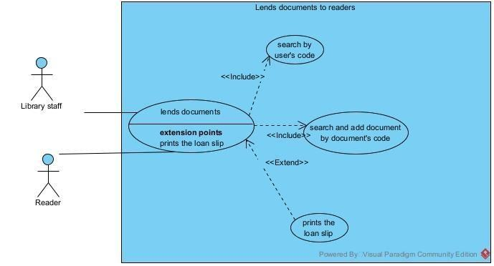
This diagram involves two actors ("Library Staff" and "Reader") and focuses on the lending process with multiple included use cases for verification and completion steps.
- Lends Documents
- Actors: Library Staff (primary), Reader (secondary)
- Relationships: Includes "Search by User's Code", "Search by Document's Code", and "Prints the Loan Slip" (all mandatory for completing the lending).
- Description: This is the core use case for borrowing. The library staff selects the document loan menu and initiates the transaction. It encompasses verifying the reader, adding documents, and finalizing the loan. The process repeats for multiple items until submission, updating the system status and ensuring accurate tracking of borrowed materials.
- Search by User's Code
- Actors: Library Staff (primary), Reader (secondary, presenting card)
- Relationships: Included by "Lends Documents" (mandatory initial step).
- Description: To identify the borrower, the staff scans the reader's card or searches by the user's code. This verifies the reader's eligibility (e.g., active status and no overdue items) before proceeding with document selection. It integrates security and personalization into the lending flow.
- Search and add document by Document's Code
- Actor: Library Staff
- Relationships: Included by "Lends Documents" (mandatory, repeatable for each item).
- Description: For each document to be borrowed, the staff scans the document code or searches by code to add it to the loan transaction. This step repeats for all items, checking availability and updating temporary status. It prevents errors like lending unavailable documents and supports efficient multi-item borrowing.
- Prints the Loan Slip
- Actor: Library Staff
- Relationships: Included by "Lends Documents" (mandatory final step).
- Description: After submitting the transaction with all items, the system generates and prints a loan slip detailing the borrowed documents, due dates, and reader information. The staff delivers it to the reader as a receipt. This completes the use case, providing a physical record and triggering system updates for inventory and reports.

PART II: ANALYSIS

1. Write Use Cases Scenario

a. Reader finds document information
Use Case | Finds document information
Actor | Reader
Precondition | The reader has accessed the main interface of the system.
Post-condition | None
Main Scenario | - The reader opens the homepage of the library system.  - The system displays the homepage interface, including the navigation bar.  - The reader selects the "Search Documents" item on the navigation bar or the homepage.  - The system displays the search page with a search bar and a "Search" button.  - The reader enters keywords related to the desired document into the search bar ("C++ Programming").  - The system displays the keywords in the input field.  - The reader clicks the "Search" button or presses the Enter key.  - The system displays a list of found results. Each result shows the following information:  - Document title (title)  - Author's name (author_name)  - Publication year  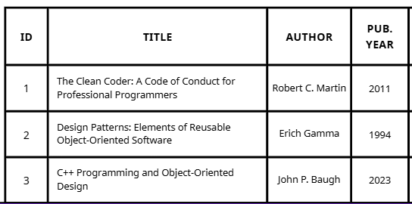  - The reader reviews the list and clicks on a specific document to view its details ( "C++ Programming and Object-Oriented").  - The system displays the detailed information page for the document, including:  - General Information: Full title, author, publisher, publication year, genre, description.  - Copy Information: A list of physical copies (DocumentCopy) with the document copy code (document_copy_code), location (position), and status (status - "Available" or "Checked out").  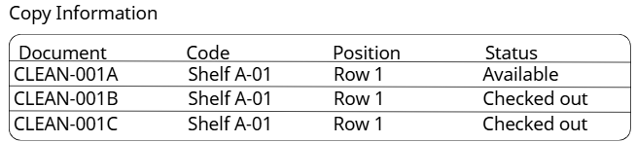
Exceptions | 7.1 . Reader does not enter a keyword  - The reader clicks the "Search" button without entering any characters into the search bar.  - The system displays an error message directly below the search bar: "Please enter information to search."  - The system remains on the search page, waiting for the reader to enter a keyword.  8.1 . No documents found  - The system does not find any DocumentTitle that matches the keyword entered by the reader.  - The system displays a clear message: "No matching documents found. Please check the keyword or try searching with a different one."  - The scenario ends.

b. Library staff lends documents to readers
Use Case | Lends documents to readers
Actor | Library staff, Reader
Precondition | - The staff member has logged into the system with their account.  - The reader is present at the counter with their reader card and the documents they wish to borrow.
Hậu điều kiện | None
Main Scenario | - The library staff member selects the "Lend Documents to Reader" function from the main menu.  - The system displays the “Lend” interface  - The library staff member takes the reader's card and manually types the card_code printed on it into the "Enter Reader Card Code" input field. After entering the code, they click the "Find" button.  - The system displays the reader's information on the screen (Full name, reader ID, photo, card_expiry), and confirms "Reader is eligible to borrow."  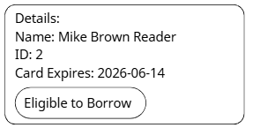  - The library staff retrieves the first document the reader wants to borrow. They find the document_copy_code printed on the document and enter this code into the "Enter Document Code" field. Then, they press the "Add" button.  - The system updates and displays the temporary loan list, which now includes the recently added document.  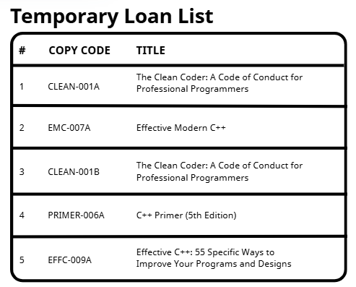  - The library staff repeats step 5 for all remaining documents the reader wishes to borrow. After all documents have been scanned, they click the "Complete Loan" button.  - The system displays a "Checkout successful!" message and generates a detailed checkout slip  - The library staff selects "Print checkout slip" and gives the slip and the documents to the reader.
Exceptions | 4.1 . Invalid Reader Card  - The system detects that the card has expired, is blocked, or the code does not exist.  - The system displays a clear error message ("Card has expired. Please renew before borrowing!").  - The scenario ends. The staff member informs the reader.  4.2 . Reader Not Eligible to Borrow  - The system detects the reader has overdue books or has already borrowed the maximum number of items allowed.  - The system displays a warning ("Reader has 2 overdue books. Cannot borrow more!").  - The scenario ends. The staff member informs the reader.  5.1 . Document Not Available for Loan  - The staff member scans a document with a status of "Checked out," "Processing," or "Lost."  - The system emits an error sound and displays the message: "This document is not available for loan!"  - The document is not added to the checkout list. The staff member sets that document aside and continues with the other items.

2. Entity Classes
Step 1: Describe the system in a paragraph
The Library Management System (LibMan) of a university allows for the management of the lifecycle of documents (such as books, textbooks, magazines) and borrowing/returning activities. The system serves three main user groups. Readers can register for a reader card online and search for document information through the search menu by entering the document title or a keyword; the system will display a list and allow viewing of detailed information. When borrowing/returning, the reader interacts directly with the staff. Library staff are the main operators, with functions to manage (add, delete, edit) documents, readers, and suppliers. When issuing a loan, the staff scans the reader's card (or searches by code), then scans the code of each document one by one until finished, and then confirms to print the loan slip. The staff also handles returned documents and inputs new documents from suppliers. Finally, the Management Board uses the system to view statistical reports on the status of documents, reader borrowing activities, and the history of data entry.
Step 2: Extract nouns appearing in the paragraph
- Nouns related to people: Management staff, Library staff, Readers, Suppliers, Staff, Student
- Nouns related to things: Documents, Library, reader card, loan slip, document code, materials
- Nouns related to the system: Library management system, search menu, loan menu, statistical reports, Keyword, statistical reports of status of documents, statistical reports of status of readers, statistical reports of status of imported documents from suppliers
Step 3: Evaluate and select nouns as entity classes or attributes
- Member: id, user_name, password, full_name, identity_code, phone_number, address, email
- Reader -> Reader(Human): id, full_name, identity_code, user_name, password, phone_number, address, email, card_code
- Staff -> class Staff(Human): id, full_name, identity_code, phone_number, address, email, position, username, password
- Supplier -> class Supplier: supplier_id, supplier_name, address, phone_number, email
- Class Author: author_id, author_name, date_of_birth, pen_name
- Class Genre: genre_id, genre_name, description
- Class Publisher: publisher_id, publisher_name, address
- Document -> Class DocumentTitle: document_title_id, title, description, publication_year, price, number_of_copy
- Document -> Class DocumentCopy: document_copy_code, status, position
- Reader Card -> Class ReaderCard: card_code, start_date, end_date, reader_id
- LoanSlip -> Class LoanSlip: loan_slip_id, loan_date, due_date
- Class LoanSlipDetail: lsd_id, book_copy_code, status, description
- Statistical reports of status of documents -> Class DocumentLog: log_id, action, change_details, timestamp
- Statistical reports of status of readers -> Class ReaderLog: log_id, action, change_details, timestamp
- Statistical reports of imported documents from suppliers -> Class SupplierLog: log_id, action, change_details, timestamp, number_of_import
- Class ReturnSlip: return_slip_id, return_date, fee
- Class ReturnSlipDetail: rsd_id, document_copy_code, status, description
- Class Invoice: invoice_id, date, total_amount, payment_date, status
- Class InvoiceDetail: invoice_detail_id, invoice_id, document_title_id, quantity, unit_price
Step 4: Determine the Cardinality Between Entities
This section analyzes the cardinality between the entity classes in your model.
- Relationship between Reader and ReaderCard: 1 - 1
- Each Reader has only one ReaderCard.
- Each ReaderCard belongs to only one Reader.
- Relationship between Reader and LoanSlip: 1 - n
  - A Reader can have many LoanSlips over time.
  - A LoanSlip belongs to only one Reader.
- Relationship between Staff and LoanSlip: 1 - n
  - A Staff member can create many LoanSlips.
  - A LoanSlip is created by only one Staff member.
- Relationship between DocumentTitle and DocumentCopy: 1 - n
- A DocumentTitle (e.g., "C++ Programming") can have many DocumentCopies (physical copies).
- A DocumentCopy belongs to only one DocumentTitle.
- Relationship between LoanSlip and DocumentCopy (via LoanSlipDetail): n - n
- This is a many-to-many relationship, resolved by the intermediate class LoanSlipDetail.
- LoanSlip and LoanSlipDetail: 1 - n (A loan slip has many detail lines).
- DocumentCopy and LoanSlipDetail: 1 - n (A document copy can appear in many different loan details over time).
- Relationship between Author, Publisher, Genre, and DocumentTitle: 1 - n
- An Author can write many DocumentTitles.
- A Publisher can publish many DocumentTitles.
- A Genre can have many DocumentTitles.
- Relationship between Reader and ReturnSlip: 1 - n
- A Reader can have many ReturnSlips.
- A ReturnSlip belongs to only one Reader.
- Relationship between ReturnSlip and DocumentCopy (via ReturnSlipDetail): n - n
- Resolved by the intermediate class ReturnSlipDetail.
- ReturnSlip and ReturnSlipDetail: 1 - n (A return slip has many detail lines).
- DocumentCopy and ReturnSlipDetail: 1 - n (A document copy can be returned on many different return slips).
- Relationship between Supplier and Invoice: 1 - n
- A Supplier can issue many Invoices.
- An Invoice belongs to only one Supplier.
- Relationship between Invoice and DocumentTitle (via InvoiceDetail): n - n
- Resolved by the intermediate class InvoiceDetail.
- Invoice and InvoiceDetail: 1 - n (An invoice has many detail lines).
- DocumentTitle and InvoiceDetail: 1 - n (A document title can appear on many different invoices).
- Relationship between Report classes and main classes: 1 - n
- A DocumentCopy can have many DocumentReport.
- A Reader can have many ReaderReport.
- A Supplier can have many SupplierReport.
Step 5: Determine the Object Relationships Between Entities
Below are the types of object relationships between the identified classes.
- Inheritance Relationship ("is a"):
- Reader is a Member.
- Staff is a Member.
- This relationship allows Reader and Staff to inherit common attributes from Member such as full_name, user_name, password
- The Report classes (DocumentReport, ReaderReport, SupplierReport) inherit to the entities they track
- Composition Relationship ("is part of"):
- LoanSlipDetail is part of LoanSlip.
- ReturnSlipDetail is part of ReturnSlip.
- InvoiceDetail is part of Invoice.
- In these cases, the "Detail" classes cannot exist independently without their parent class. Their lifecycle is completely dependent on the parent.
- Aggregation Relationship ("has a"):
- A DocumentTitle has an Author, a Publisher, and a Genre. These objects (Author, Publisher, Genre) have independent lifecycles and can exist without a DocumentTitle.
- Reader is aggregation with ReaderCard (a very strong 1-1 relationship).
- Reader is a aggregation with LoanSlip and ReturnSlip (the reader "performs" borrowing/returning transactions).
- DocumentCopy is a aggregation with DocumentTitle (a copy "belongs to" a document title).
- Staff is aggregation with ReturnSlip, Invoice (the staff "processes" the transactions).
- Association Relationship:
- Supplier is associated with Invoice (a supplier "issues" an invoice).
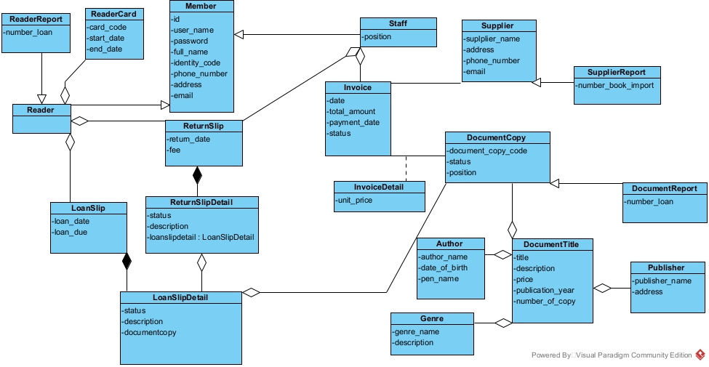

3. Boundary Class and Control Class

a. Reader finds document information
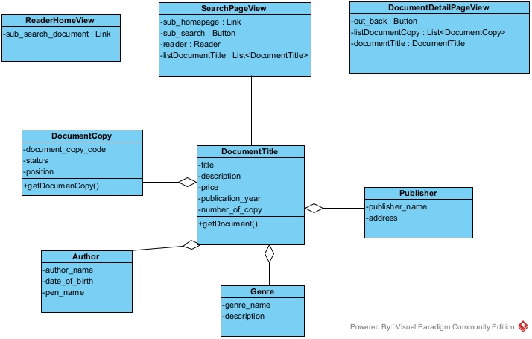
1. ReaderHomeView
This class represents the main home interface that the reader first sees.
- Attributes:
  - sub_search_document : Link: A link to navigate the user to the document search page.
2. SearchPageView
This class represents the page where the user performs a search and views the list of results.
- Attributes:
  - sub_homepage : Link: A link to return to the home page.
  - sub_search : Button: A button to initiate the search action.
  - reader : Reader: Stores information about the Reader object performing the search.
  - listDocumentTitle : List<DocumentTitle>: A list of the found DocumentTitle objects.
3. DocumentDetailPageView
This class represents the page that displays all detailed information about a specific document title.
- Attributes:
  - out_back : Button: A button to return to the previous search results page.
  - listDocumentCopy : List<DocumentCopy>: A list of DocumentCopy objects (physical copies) that belong to this document title.
  - documentTitle : DocumentTitle: The DocumentTitle object currently being viewed.

b. Library staff lends documents to readers
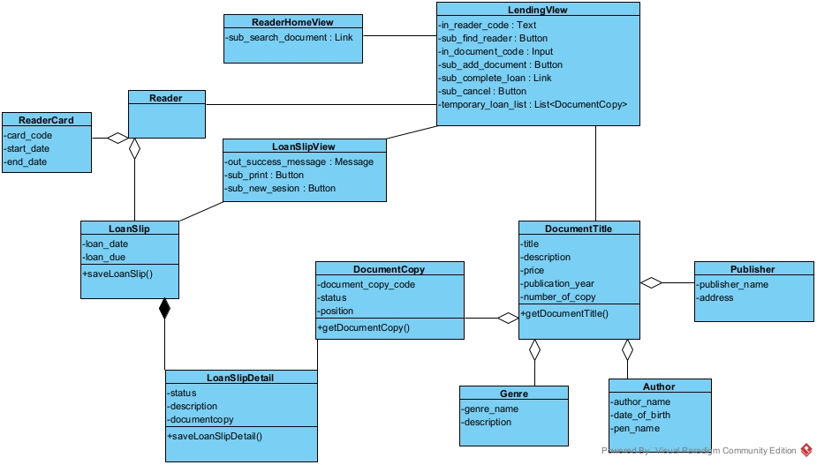
1. ReaderHomeView
This class represents the main home interface that the reader first sees.
- Attributes:
  - sub_search_document : Link: A link to navigate the user to the document search page.
2. LendingView
This class represents the main interface used by library staff to process a document loan for a reader.
- Attributes:
  - in_reader_code : Text: A text field to enter the reader's card code.
  - sub_find_reader : Button: A button to find and validate the reader.
  - in_document_code : Input: An input field to enter the code of the document copy being loaned.
  - sub_add_document : Button: A button to add the document copy to the temporary loan list.
  - sub_complete_loan : Link: A link to finalize the loan process and create the loan slip.
  - sub_cancel : Button: A button to cancel the entire current lending session.
  - temporary_loan_list : List<DocumentCopy>: A list of DocumentCopy objects that have been added to the session but not yet finalized.
3. LoanSlipView
This class represents the confirmation screen shown after the loan process is successfully completed.
- Attributes:
  - out_success_message : Message: A message to display the successful completion message.
  - sub_print : Button: A button to print the loan slip (receipt).
  - sub_new_sesion : Button: A button to start a new session (return to LendingView).
4. Activity Modeling

a. Reader finds document information
- From Processing at HomePage, when the user "Choose[s] Search Document", the system transitions to Processing at SearchPage.
- At Processing at SearchPage, the system will Display Search Interface. After this, the following flows occur:
- When the user Enter[s] keyword into search bar, the system will display keyword in input field.
- When the user Click[s] search button, the system will Display list of found document.
- From the Display list of found document state, if the user click[s] on specific document, the system transitions to Processing At DocumentDetailPage.
- At Processing At DocumentDetailPage, the system will Display the detailed information, and the process then ends.
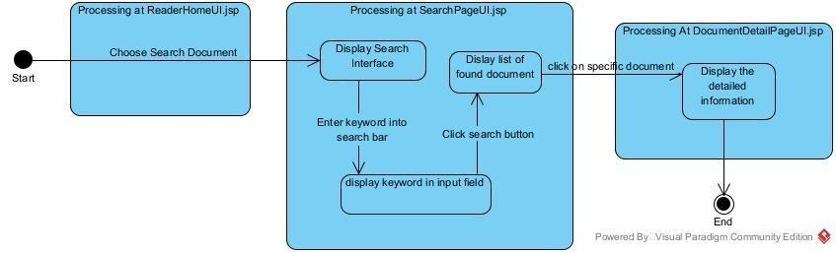
Scenario v.2 for the Reader's Document Search Module
- On the main interface (ReaderHomeUI.jsp), the Reader selects the "Search Document" function.
- The ReaderHomeUI.jsp class calls the SearchPageUI.jsp class.
- The system displays the search interface (SearchPageUI.jsp) to the Reader.
- The Reader enters a keyword into the search bar.
- The SearchPageUI.jsp displays the keyword as it is typed.
- The Reader clicks the search button.
- The SearchPageUI.jsp class sends a Call (a search request with the keyword) to the DocumentTitle class.
- The DocumentTitle class executes the search and returns a list of found DocumentTitle objects (via getDocumentTitle()).
- The SearchPageUI.jsp class receives and processes the returned list.
- The SearchPageUI.jsp class displays the list of found documents to the Reader.
- The Reader clicks on a specific document from the list to see its details.
- The SearchPageUI.jsp class calls the DocumentDetailPageUI.jsp class, passing the context of the selected DocumentTitle.
- The DocumentDetailPageUI.jsp class sends a Call to the DocumentCopy class to find all associated physical copies for the selected document.
- The DocumentCopy class retrieves and returns a list of DocumentCopy objects (via getDocumentCopiesByTitleId()).
- (Internal Processing) The DocumentDetailPageUI.jsp class receives and processes the list of copies.
- The DocumentDetailPageUI.jsp class displays the complete detailed information to the Reader.
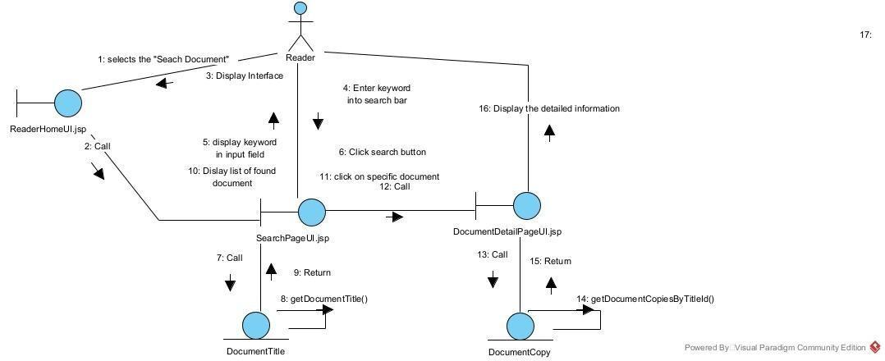

b. Library staff lends documents to readers
- From StaffHomeUI.jsp, when the user selects the "Lend Documents to Reader" function, the system transitions to LendUI.jsp.
- Within LendUI.jsp, the system Displays the "Lend" interface. The process continues as the user Enter[s] Reader Card Code and click[s] Find button, which leads to the system display[ing] the reader's information. Following this, the user Enter[s] Document Code and click[s] Add button, which updates and displays the temporary loan list.
- When the user click[s] the Complete Loan button, the system transitions to CheckOutUI.jsp.
- At CheckOutUI.jsp, the system displays [a] successful Loan slip. Following the Print checkout slip action, the process ends.

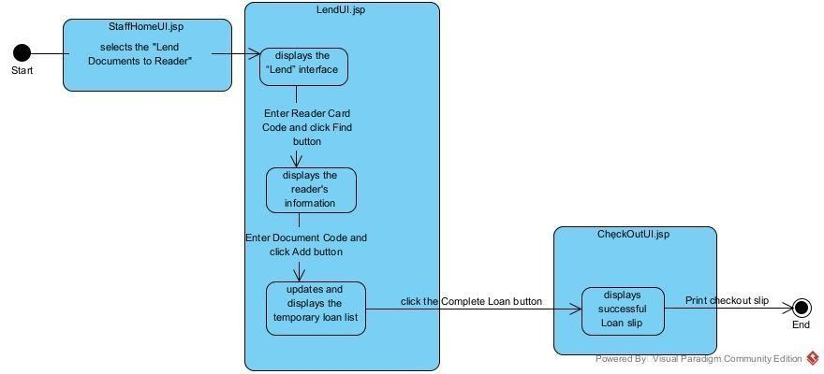
Scenario v.2: Lending Documents
- At the main interface (StaffHomeUI.jsp), the Library Staff selects "Lend to Reader".
- The StaffHomeUI.jsp class sends a call to the LendingUI.jsp class.
- The LendingUI.jsp Display[s] the "Lend" Interface to the Library Staff.
- The Library Staff Enter[s] Reader card code and click[s] find button.
- The LendingUI.jsp sends a Call to the Reader class to find the reader.
- The Reader class executes its internal getReader() method to retrieve its data.
- The Reader class Return[s] its information to LendingUI.jsp.
- The LendingUI.jsp Display[s] the reader's information to the Library Staff.
- The Library Staff Enter[s] Document code and click[s] add button.
- The LendingUI.jsp sends a Call to the DocumentCopy class to get the item's details.
- The DocumentCopy class executes its internal getDocumentCopy() method.
- The DocumentCopy class Return[s] the item's information to LendingUI.jsp.
- The LendingUI.jsp update[s] and display[s] the temporary list for the Library Staff.
- The Library Staff click[s] complete Loan.
- The LendingUI.jsp sends a Call to the CheckOutUI.jsp class, delegating the checkout process.
- The CheckOutUI.jsp sends a Call to the LoanSlip class to create and save the loan.
- The LoanSlip class calls its own SaveLoanSlip() method to write to the database.
- The LoanSlip class sends a Call to the LoanSlipDetail class to save the specific items.
- The LoanSlipDetail class calls its own LoanSlipDetail() method (or a save method).
- The LoanSlipDetail class sends a Return to LoanSlip (confirming its save).
- The LoanSlip class sends a Return to CheckOutUI.jsp (confirming the entire slip is saved).
- The CheckOutUI.jsp displays [the] successful Loan slip to the Library Staff.
- The Library Staff performs the print Loan slip action.
- The CheckOutUI.jsp sends a Return to LendingUI.jsp (to return to the lending interface).
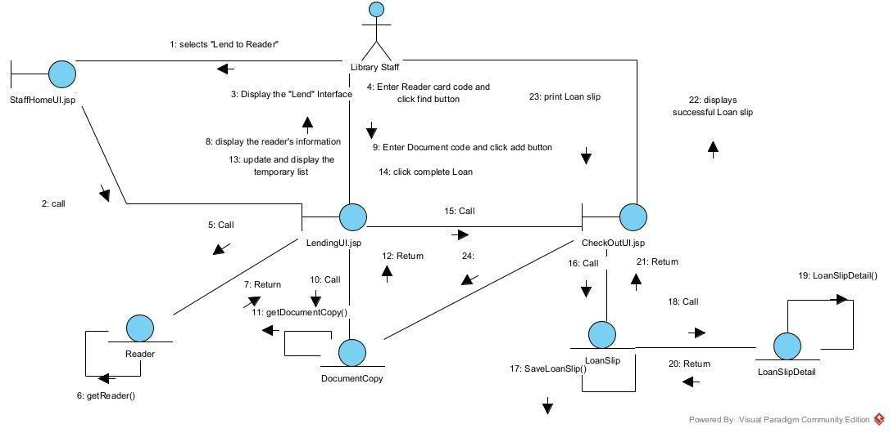

PART III: DESIGN

1. Entity Class Design
Step 1: Classes are supplemented with an ID attribute, with the exception of account-related or inherited classes.
Step 2: The attributes of the classes are updated with data types from the Java programming language (e.g., int, String, Date, double).
Step 3: The LoanSlip class's relationships are defined, showing it is associated with DocumentCopy (via LoanSlipDetail) and Reader.
Step 4: By adding component attributes to represent the composition and aggregation relationships, the entity class diagram for the design phase is obtained.

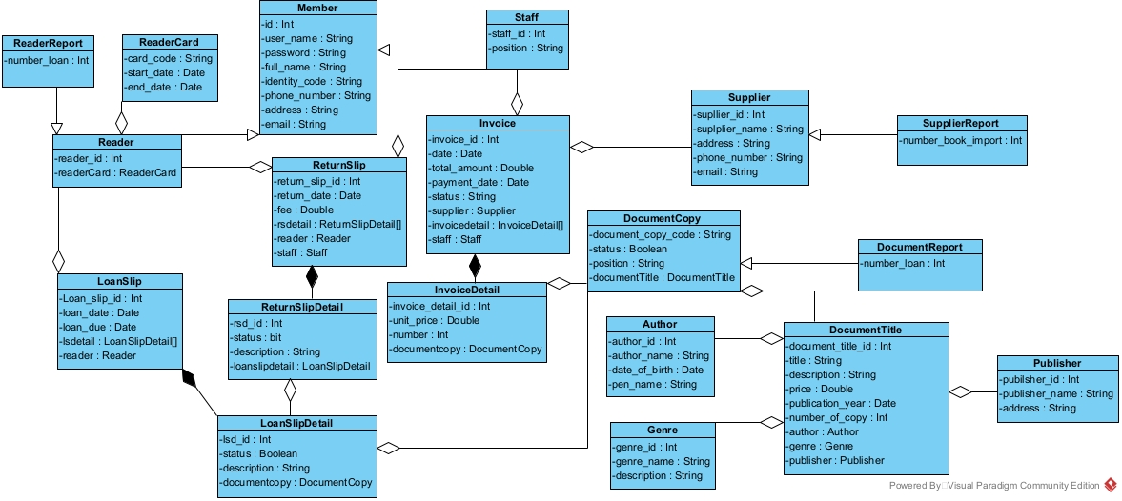

2. Database Design
Step 1: Each entity class is mapped to a corresponding table:
- Class Member-> table Member
- Class DocumentTitle-> table DocumentTitle
- ....
Step 2: Convert the non-object attributes of an entity class into columns of the corresponding table:
- Member has the columns: id, name, …
- DocumentTitle: document_title_id, …
- ....
Step 3: Translate the cardinality of relationships between entity classes into relationships between the tables.
Step 4: Add key attributes. The primary key is set on the id column for each respective table.
Step 5: For the attributes of the statistics/reporting classes -> all corresponding statistics tables are eliminated.
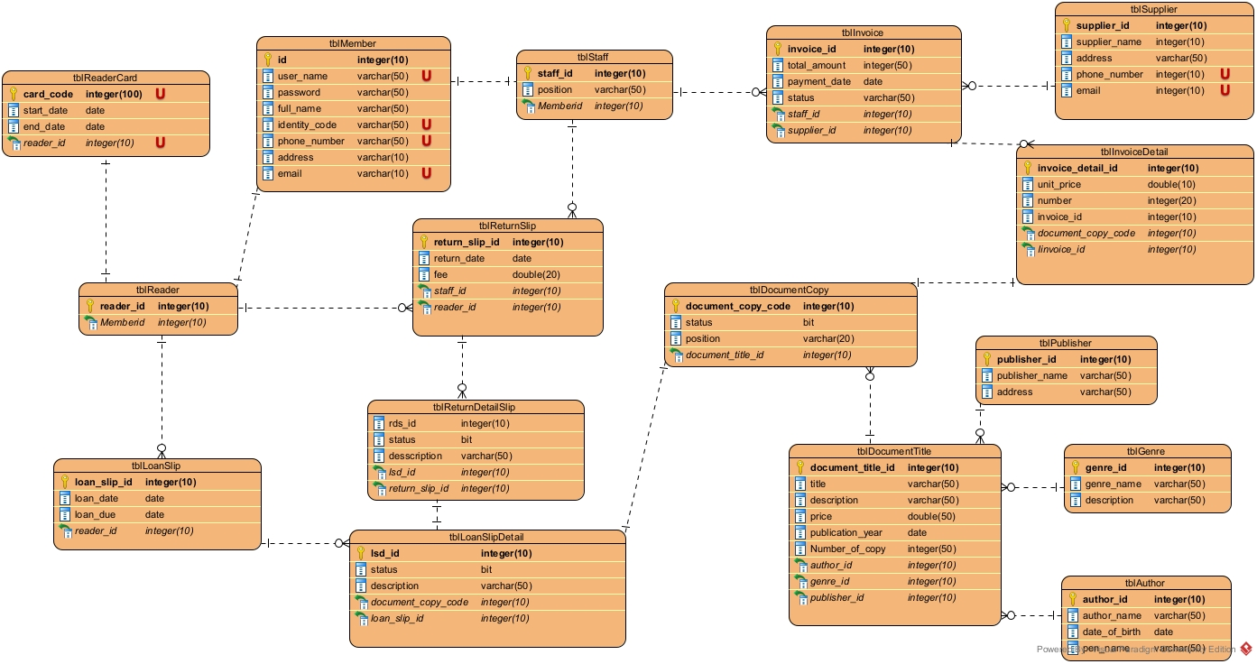

3. Detailed Design for module

a. Static Design for module reader finds document information
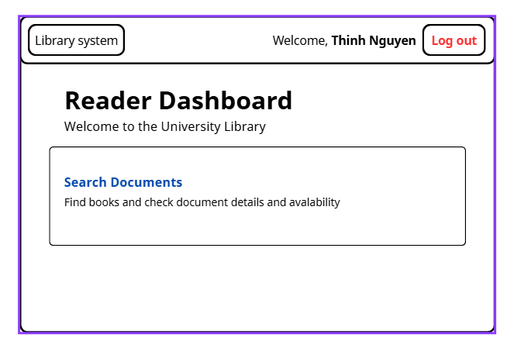
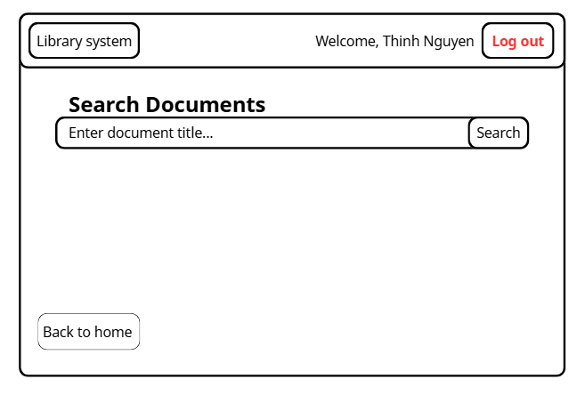
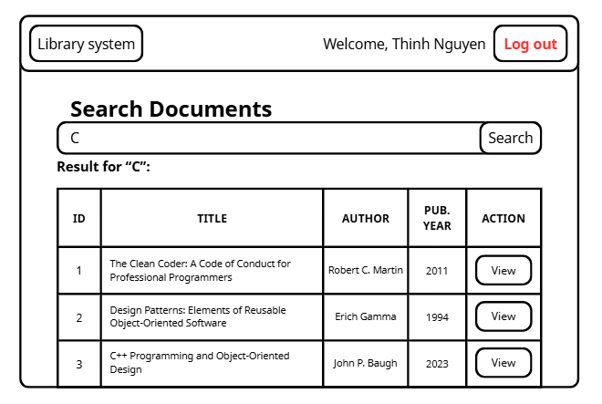
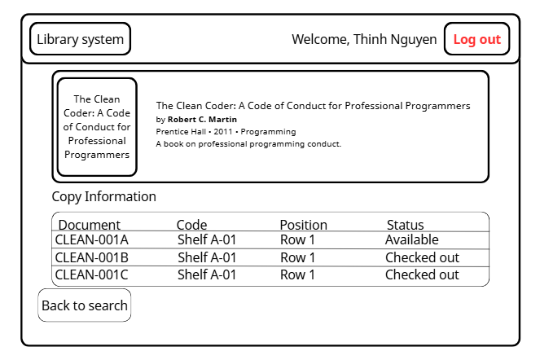
The interfaces for this function are designed as shown in the figure. The class diagram is designed correspondingly in the figure:
- The interface layer has jsp pages:LoginUI.jsp, ReaderHomeUI.jsp, SearchPageUI.jsp, DocumentDetailPageUI.jsp.
- The controller layer has classes: LoginController, DocumentTitleController, DocumentDetailController
- The data manipulation layer has classes: DAO, ReaderDAO, DocumentTitleDAO, DocumentCopyDAO, StaffDAO.
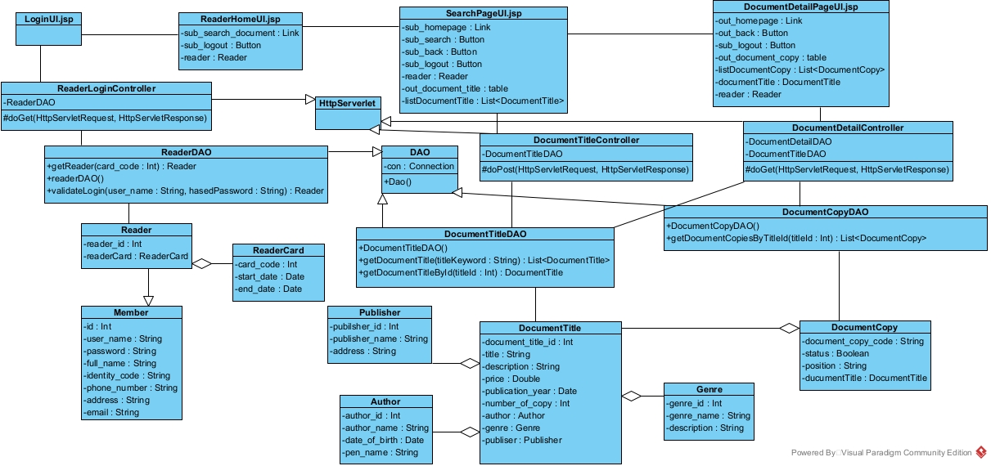

b. Static Design for Library staff lends documents to readers

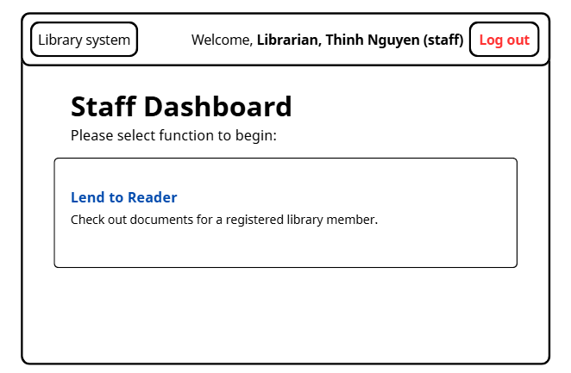
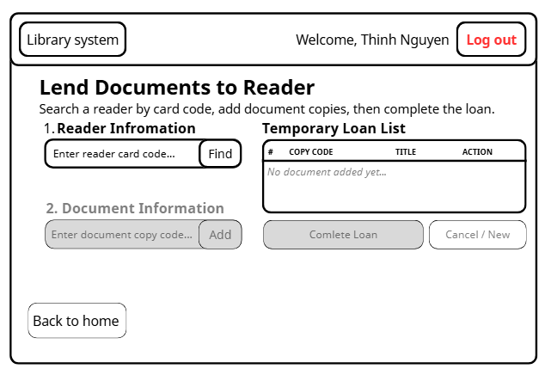
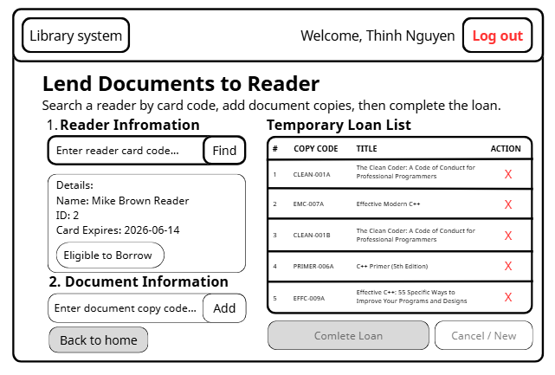
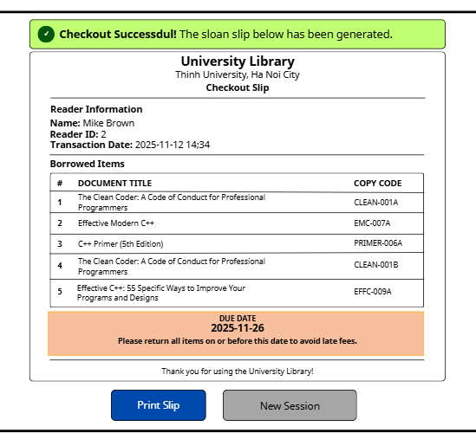
The interfaces for this function are designed as shown in the figure. The class diagram is designed correspondingly in the figure:
- The interface layer has jsp pages: LoginUI.jsp, StaffPageUI.jsp, LendingUI.jsp, CheckOutUI.jsp.
- The data Controller layer has classes: LoginController, ReaderController, LoanSlipController, DocumentCopyController.
- The data manipulation layer has classes: DAO, DocumentCopyDAO, StaffDAO, ReaderDAO, LoaSlipDAO.

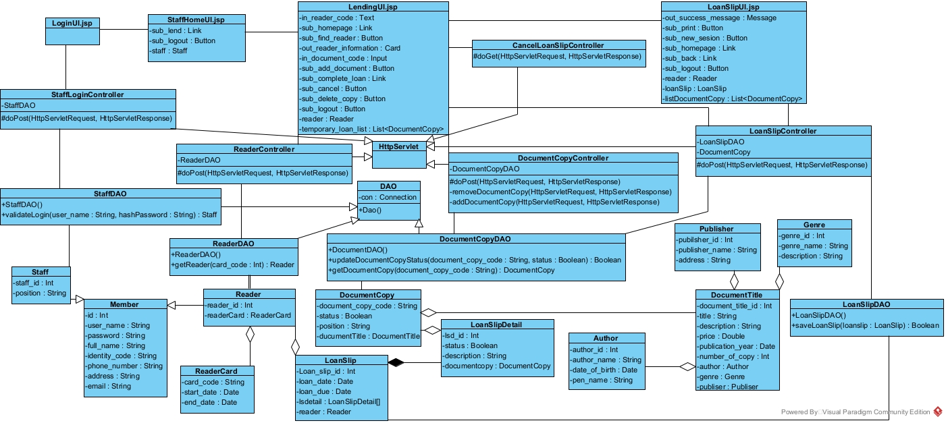

4. Activity Design

a. Module reader finds document information
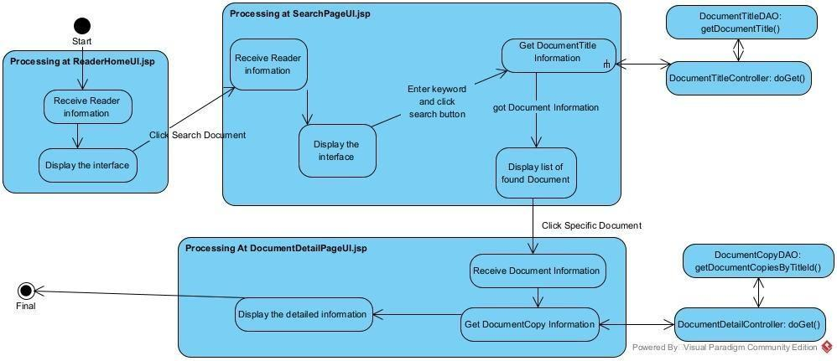
- The Library Staff clicks the "Search Document" function on the ReaderHomeUI.jsp interface.
- ReaderHomeUI.jsp sends a Call request to SearchPageUI.jsp.
- SearchPageUI.jsp displays (Display) the document search interface.
- The Library Staff enters a keyword and clicks the search button.
- SearchPageUI.jsp sends a Call request (containing the keyword) to the DocumentTitleController.
- The DocumentTitleController receives the request and calls its own doPost() method.
- The DocumentTitleController sends a Call request to the DocumentTitleDAO.
- The DocumentTitleDAO sends a Call request to the DocumentTitle (Entity) to query data.
- The DocumentTitle (Entity) executes the getDocumentTitle() method.
- The DocumentTitle (Entity) initializes (DocumentTitle()) the document title object(s) to encapsulate data.
- The DocumentTitle (Entity) returns (Return) the DocumentTitle object(s) to the DocumentTitleDAO.
- The DocumentTitleDAO returns (Return) a list of DocumentTitle objects to the DocumentTitleController.
- The DocumentTitleController returns (Return) the result list to SearchPageUI.jsp.
- SearchPageUI.jsp displays (Display) the list of found document titles to the Library Staff.
- The Library Staff clicks a specific document (Clicks a Specific Document) from the results list.
- SearchPageUI.jsp sends a Call request (containing the selected document's info) to DocumentDetailPageUI.jsp.
- DocumentDetailPageUI.jsp sends a Call request to the DocumentDetailController.
- The DocumentDetailController receives the request and calls its own doGet() method.
- The DocumentDetailController sends a Call request to the DocumentCopyDAO.
- The DocumentCopyDAO sends a Call request to the DocumentCopy (Entity) to query data.
- The DocumentCopy (Entity) executes the getDocumentCopiesByTitleId() method.
- The DocumentCopy (Entity) initializes (DocumentCopy()) the document copy object(s).
- The DocumentCopy (Entity) returns (Return) the DocumentCopy object(s) to the DocumentCopyDAO.
- The DocumentCopyDAO returns (Return) the list of DocumentCopy objects to the DocumentDetailController.
- The DocumentDetailController returns (Return) the detailed list (of copies) to DocumentDetailPageUI.jsp.
- DocumentDetailPageUI.jsp displays (Display) the detailed information of the selected document (including the list of copies) to the Library Staff.
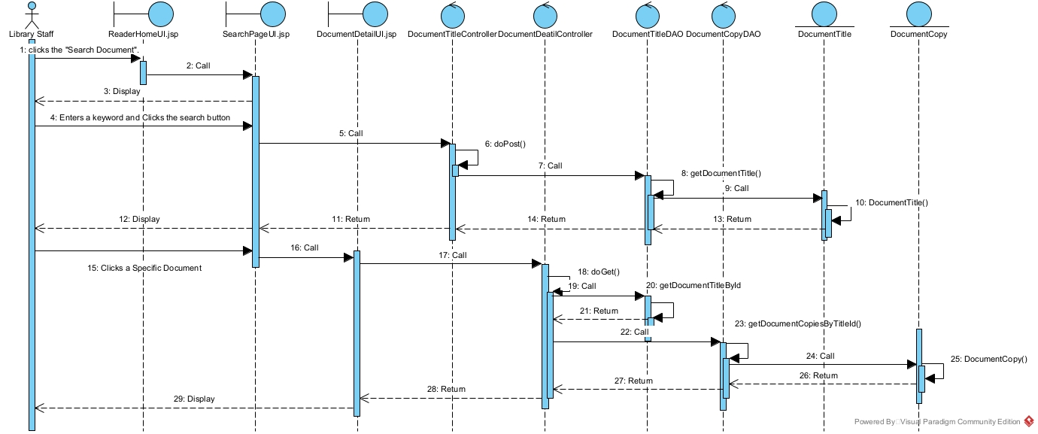

b. Module library staff lends documents to readers
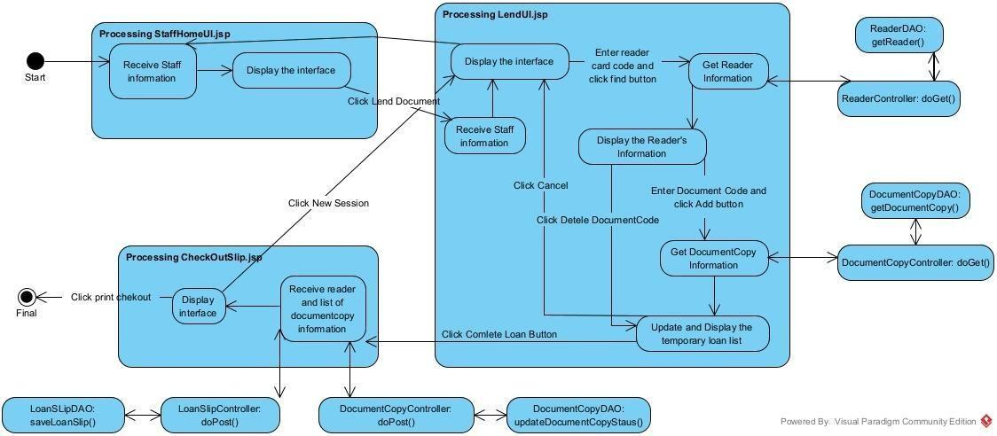
- The Library Staff selects the "Lend Document" function on the StaffHomeUI.jsp interface.
- StaffHomeUI.jsp sends a Call request to LendUI.jsp.
- LendUI.jsp displays (Display) the document lending interface.
- The Library Staff enters the "reader card code" and clicks the "find button".
- LendUI.jsp sends a Call request (containing the card code) to the ReaderController.
- The ReaderController receives the request and calls its own doPost() method.
- The ReaderController sends a Call request to the ReaderDAO.
- The ReaderDAO sends a Call request to the Reader (Entity) to query data.
- The Reader (Entity) executes the getReader() method.
- The Reader (Entity) initializes (Reader()) a reader object to encapsulate the data.
- The Reader (Entity) returns (Return) the Reader object to the ReaderDAO.
- The ReaderDAO returns (Return) the Reader object to the ReaderController.
- The ReaderController returns (Return) the Reader object to LendUI.jsp.
- LendUI.jsp displays (Display) the information of the found reader.
- The Library Staff enters the "Document Code" and clicks the "Add button".
- LendUI.jsp sends a Call request to the DocumentCopyController.
- The DocumentCopyController receives the request and calls its own doPost() method.
- The DocumentCopyController sends a Call request to the DocumentCopyDAO.
- The DocumentCopyDAO sends a Call request to the DocumentCopy (Entity) to query data.
- The DocumentCopy (Entity) executes the getDocumentCopy() method.
- The DocumentCopy (Entity) initializes (DocumentCopy()) a document copy object.
- The DocumentCopy (Entity) returns (Return) the DocumentCopy object to the DocumentCopyDAO.
- The DocumentCopyDAO returns (Return) the DocumentCopy object to the DocumentCopyController.
- The DocumentCopyController returns (Return) the DocumentCopy object to LendUI.jsp.
- LendUI.jsp displays (Display), updating the "Temporary Loan List".
- The Library Staff clicks the "Complete Loan Button" to confirm the loan.
- LendUI.jsp sends a Call request (containing the Reader and Temporary Loan List info) to CheckOutSlip.jsp.
- CheckOutSlip.jsp sends a Call request (containing all transaction information) to the LoanSlipController.
- The LoanSlipController receives the request and calls its own doPost() method.
- (Update Status) The LoanSlipController sends a Call request to the DocumentCopyDAO.
- The DocumentCopyDAO executes updateDocumentCopyStatus() (to change the documents' status to "On Loan").
- The DocumentCopyDAO returns (Return) the update result to the LoanSlipController.
- (Package Loan Slip) The LoanSlipController sends a Call request to the LoanSlip (Entity).
- The LoanSlip (Entity) initializes a (LoanSlip()) object to encapsulate the loan slip data.
- (Package Loan Slip Detail) The LoanSlipController sends a Call request to the LoanSlipDetail (Entity).
- The LoanSlipDetail (Entity) initializes (LoanSlipDetail()) the loan slip detail objects.
- (Save Transaction) The LoanSlipController sends a Call request (containing the LoanSlip and LoanSlipDetail objects) to the LoanSlipDAO.
- LoanSlipDAO thực thi saveLoanSlip() để lưu toàn bộ giao dịch vào cơ sở dữ liệu.
- The LoanSlipDAO executes saveLoanSlip() to save the entire transaction to the database.
- The LoanSlipDAO returns (Return) the save result to the LoanSlipController.
- The LoanSlipController returns (Return) a success confirmation to CheckOutSlip.jsp.
- CheckOutSlip.jsp displays (Display) the completed transaction details to the Library Staff.
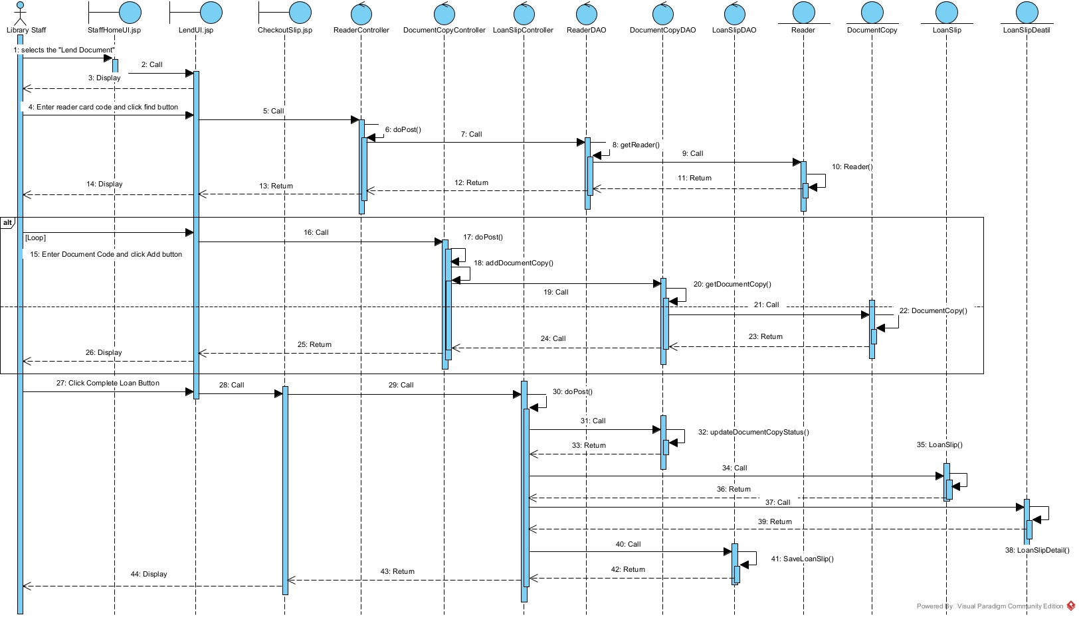

5. Package Design
For the system, the packages are designed according to the structure:
- Entity classes are placed together in the model package.
- DAO classes are placed together in the dao package.
- Controller classes are placed together in the controller package.
- JSP pages are kept in the appweb package. The View package is divided into smaller sub-packages corresponding to the interfaces for different users:
- Pages for functions related to members are placed in the member package.
- Pages for functions related to staff are placed in the staff package.
- Pages for functions related to readers are placed in the reader package.
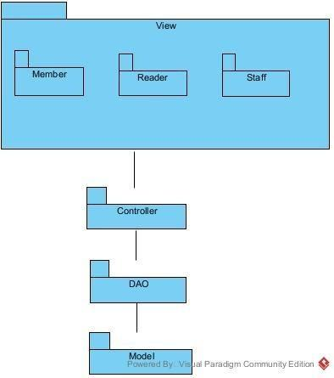

6. Deployment Desgin
For the system, the deployment are designed according to the structure:
- Client-Tier: Users send requests using a Web Browser (Chrome 115+).
- Application-Tier: Apache Tomcat 9.0 on the Server node receives requests and executes the application logic (LibraryWeb.war).
- Data-Tier: The application server queries and stores data in MySQL Server 8.0 on a Database node.
Communication Paths:
- Client <-> Server: Uses the secure HTTPS protocol (TCP/443).
Server <-> Database: Uses a JDBC connection (TCP/3306) to interact with MySQL.
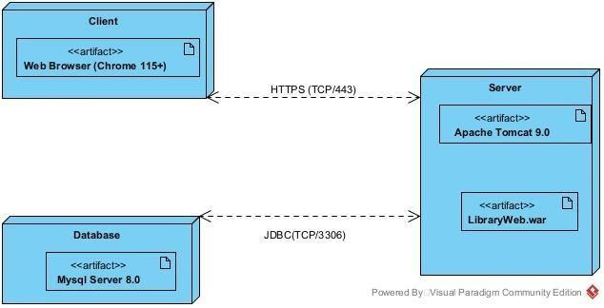

PART IV: SYSTEM IMPLEMENTATION

1. Project Organization

a. Controller Package
Contains Servlets and Filters, responsible for receiving requests, dispatching business logic, and handling authentication.
- CancelLoanController.java
- DocumentCopyController.java (has warnings)
- DocumentDetailController.java
- DocumentTitleController.java
- LoanSlipController.java (has warnings)
- LogoutController.java
- package-info.java
- PasswordUtil.java
- ReaderAuthenticationFilter.java
- ReaderController.java
- ReaderLoginController.java
- StaffAuthenticationFilter.java
- StaffLoginController.java

b. Dao (Data Access Object) Package
Contains classes responsible for accessing and manipulating the database directly.
- DAO.java
- DocumentCopyDAO.java
- DocumentTitleDAO.java
- LoanSlipDAO.java (has warnings)
- package-info.java
- ReaderDAO.java
- StaffDAO.java

c. Model Package
Contains entity classes (POJO - Plain Old Java Objects) representing the system's data objects.
- Author.java
- DocumentCopy.java
- DocumentTitle.java
- Genre.java
- LoanSlip.java
- LoanSlipDetail.java
- Member.java
- package-info.java
- Publisher.java
- Reader.java
- ReaderCard.java
- Staff.java

d. Webapp Directory
Contains user interface (View) files and static web resources.
- view/
- member/
- LoginUI.jsp
- reader/
- DocumentDetailPageUI.jsp
- ReaderHomeUI.jsp
- SearchPageUI.jsp
- staff/
- LendingUI.jsp (has warnings)
- LoanSlipUI.jsp
- StaffHomeUI.jsp
- style.css
- WEB-INF/
- lib/ (This directory contains the .jar files listed in section 5)
- web.xml (Deployment Descriptor)
- META-INF/

e. Libraries
The .jar files used in the project are located in Java Resources > Libraries > Web App Libraries and are also copied into src/main/webapp/WEB-INF/lib.
- jstl-1.2.jar
- mysql-connector-j-9.4.0.jar
Additionally, the project also uses:
- JRE System Library [JavaSE-17]
- Server Runtime [Apache Tomcat v9.0]

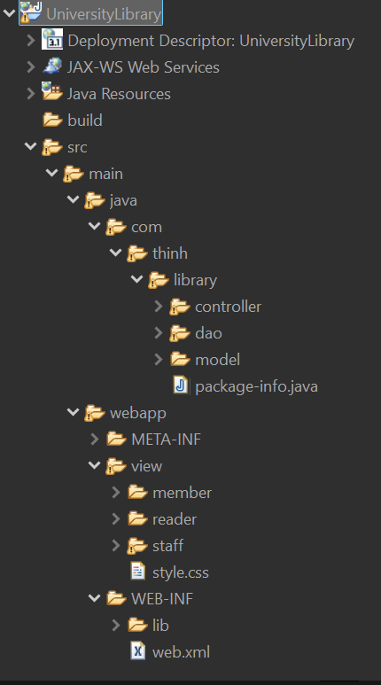
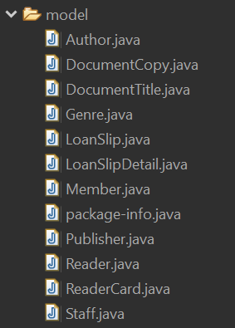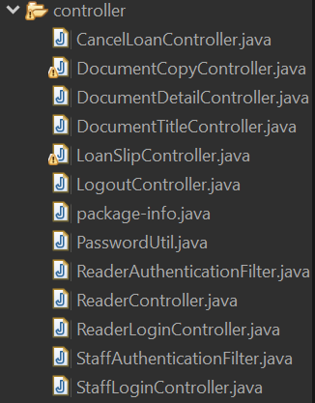
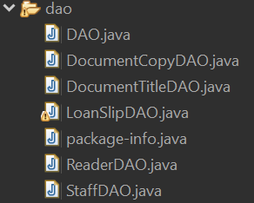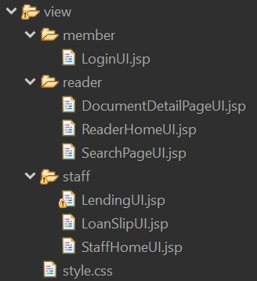
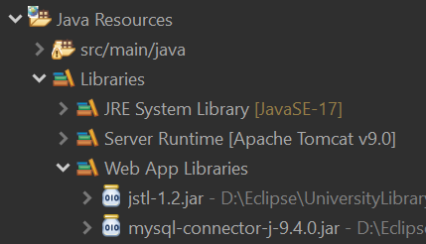

2. Interface

a. Module reader finds document information
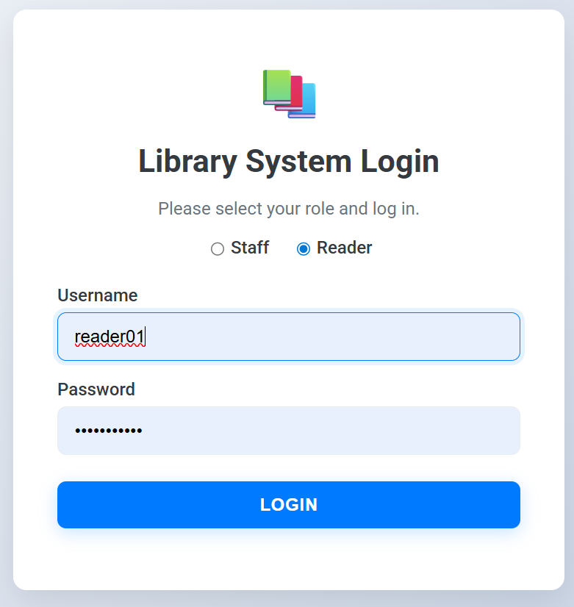
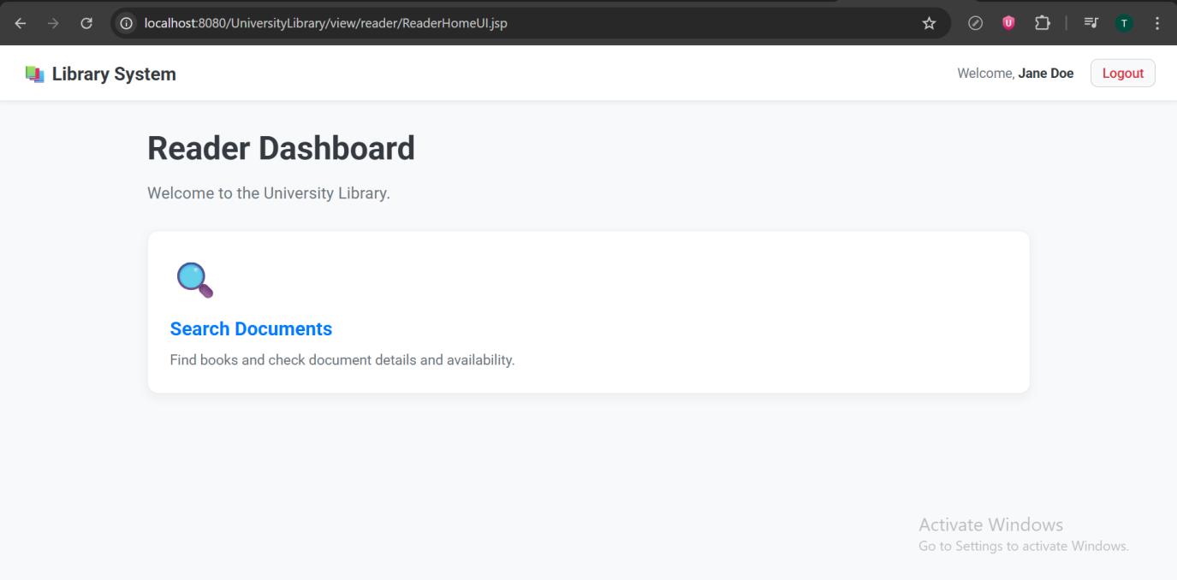
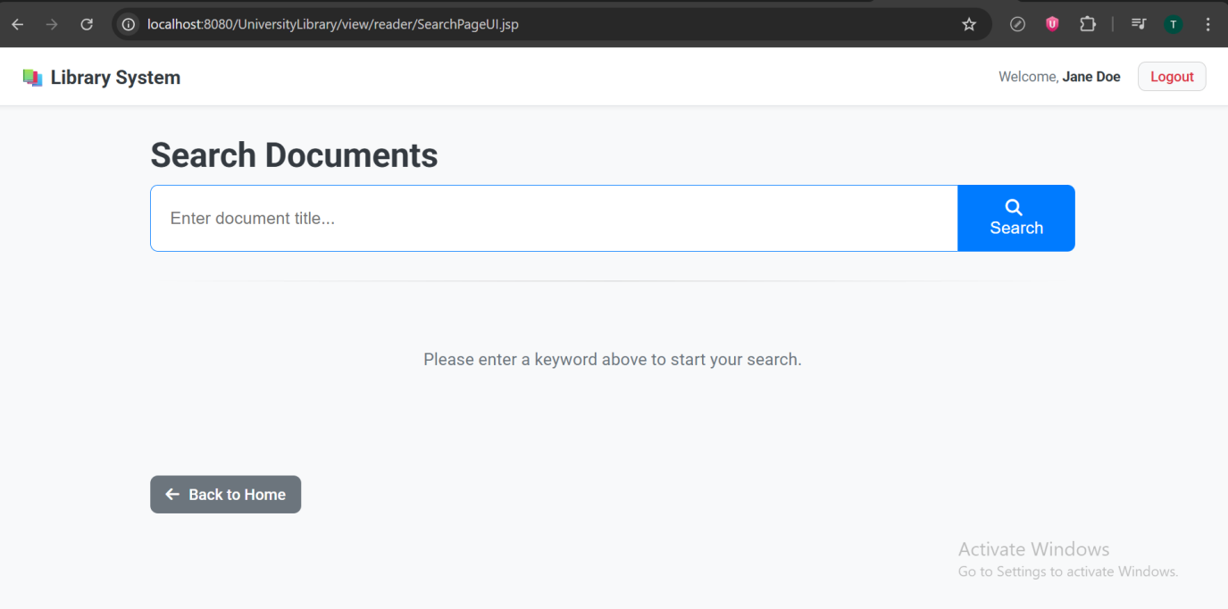
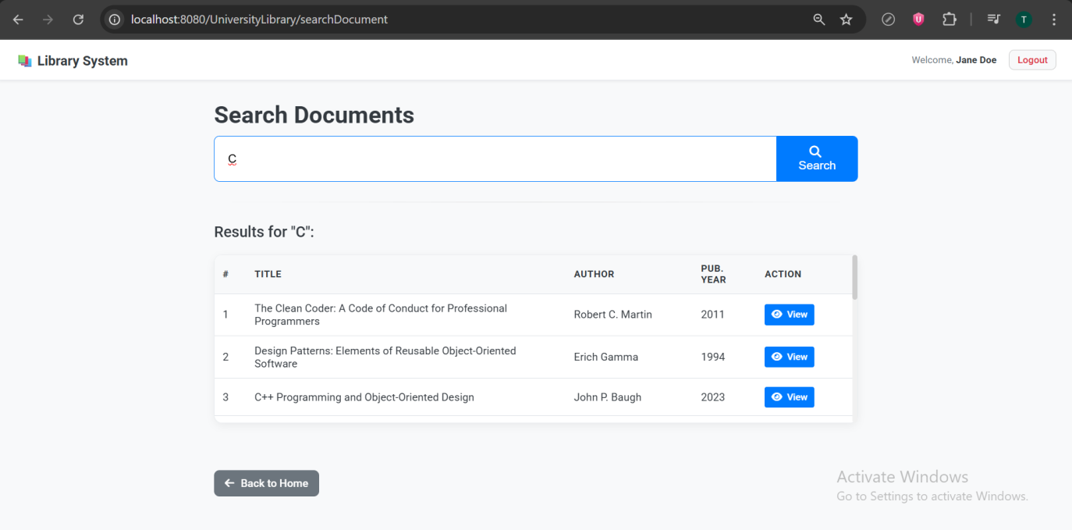
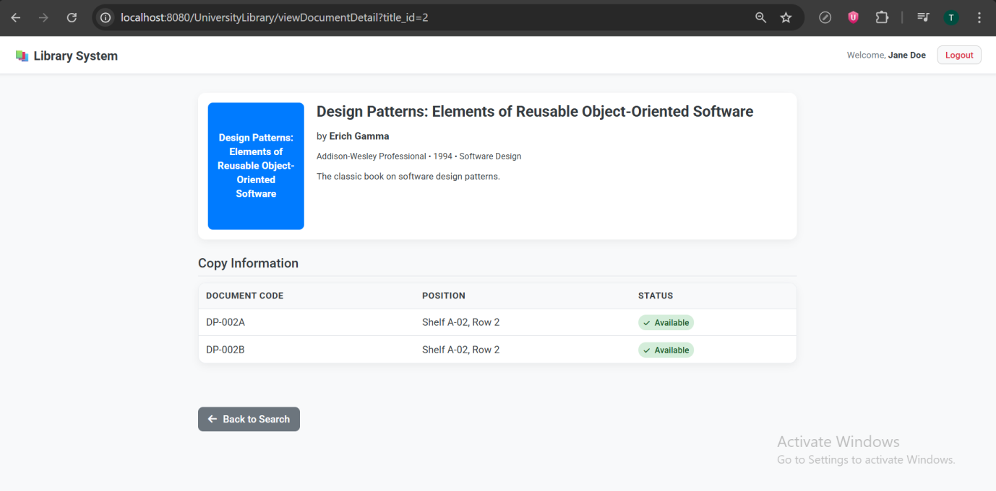

b. Module library staff lends documents to readers
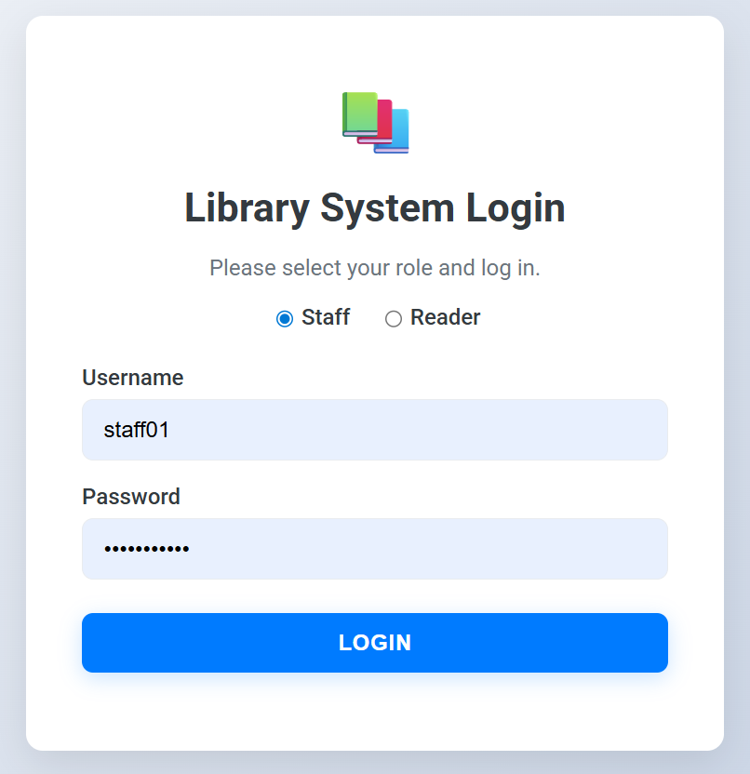
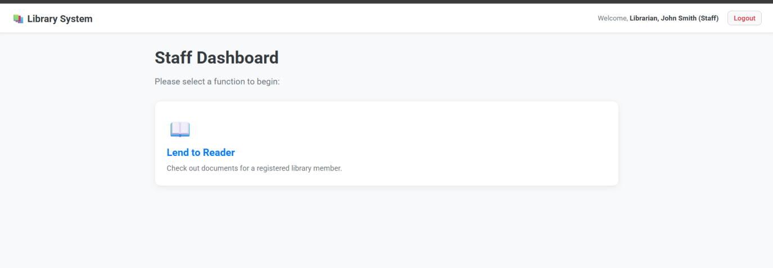
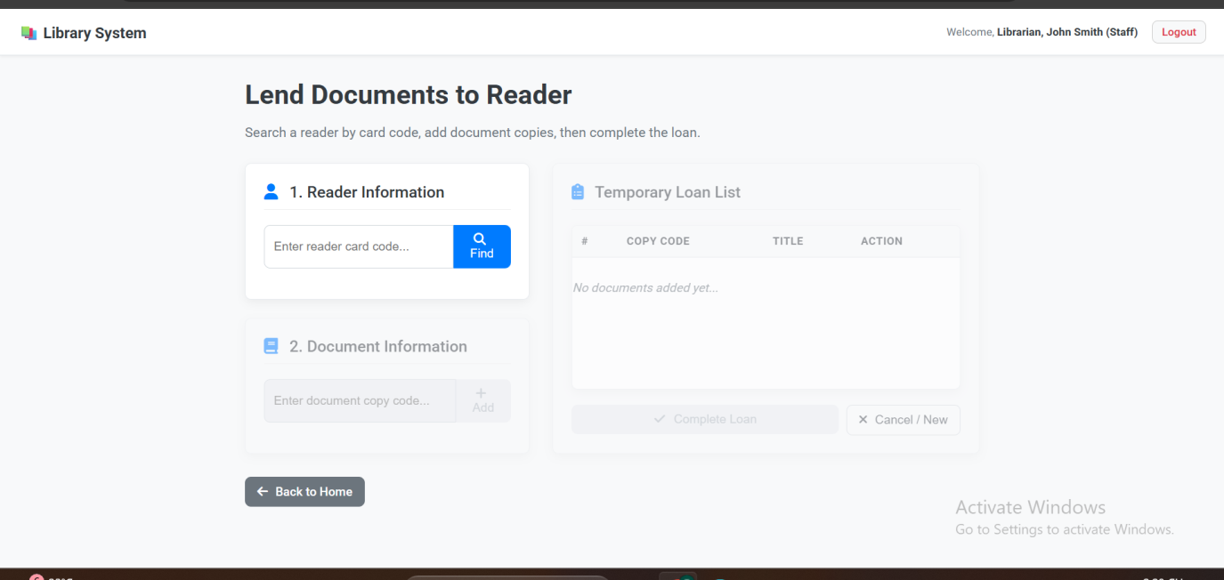
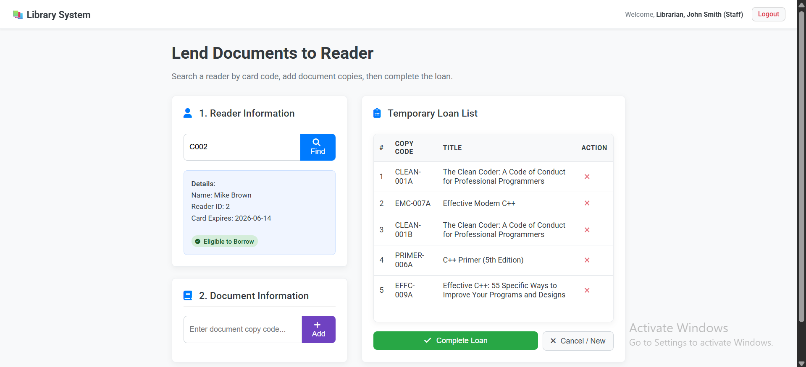
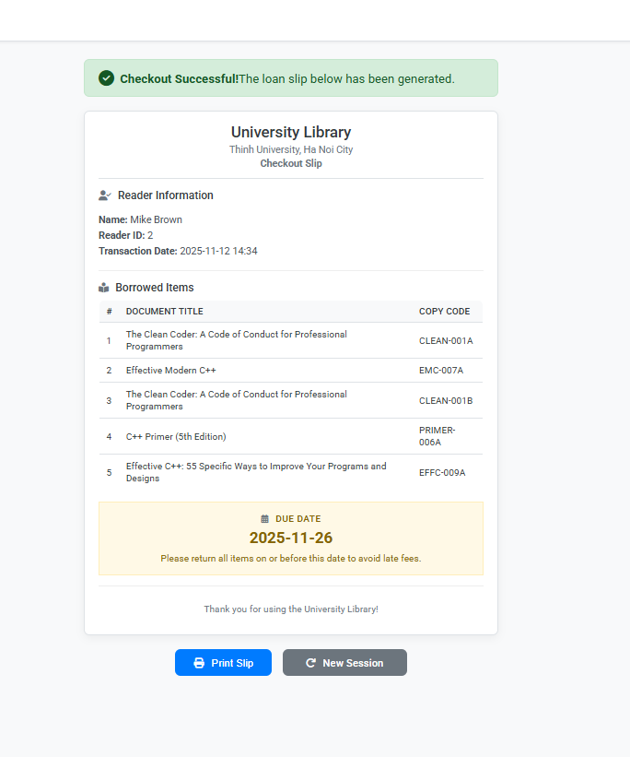

3. Coding
Link: https://drive.google.com/drive/folders/1jLiGocCaRtvEC4MbkUStFjKUq6kSs3Ue?usp=sharing

